
ELMO COMPILER
Intermediate Code Generation (ICG) Report
SCS3306 - Compiler Construction
Group 3

Members
KARUGA LEO MUNENE - SCS3/146815/2023
OCHANDA ERIC KUMENDA - SCS3/6959/2023
WANGARI MORRIS NGUMO - P15/1906/2022
KOECH SANDRA CHEROP - SCS3/146544/2023

Date: 12th May, 2026

Technical Deep Dive: How our icg.go Works
The Intermediate Code Generator (ICG) acts as Phase 3 of the compiler. It receives the concrete syntax tree generated by our parser and translates it into Three-Address Code (3AC) represented as a flat list of Quadruples.

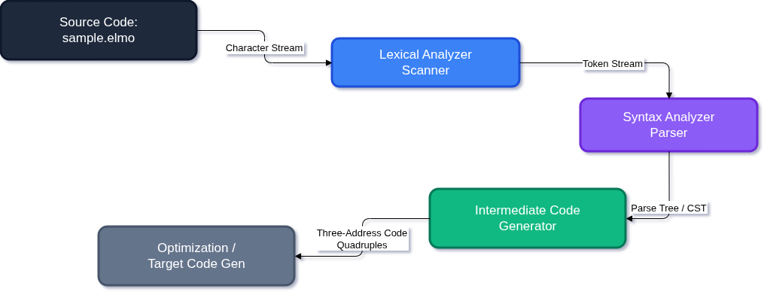
Compiler Pipeline Architecture

1. The Quadruple Representation
At the core of our ICG is the Quad data structure. A quadruple consists of four main fields:
- Op: The operator or instruction (i.e, ADD, MUL, COPY, IFF, GOTO, LABEL, DECL).
- Arg1: The first operand (can be a variable, literal or a temporary).
- Arg2: The second operand.
- Result: The destination where the output is stored, or the target label for jumps.
The ICG struct maintains the global state: a slice of Quad structs, a tempNum counter for generating fresh temporary variables (t1, t2, t3, ...), and a labelNum counter for generating unique jump labels (L1, L2, ...).

2. AST Traversal & Transformation Strategy
The transformation algorithm performs a Depth-First, Post-Order Traversal of the syntax tree. The entry point is Generate(node *Node), which recursively dispatches to specific handler functions based on the Node.Type (e.g, genAssignStmt, genIfStmt, genExpr).
By evaluating the children of a node before the parent, the generator ensures that inner expressions (like multiplication) are converted into quadruples before outer expressions (like addition). This naturally preserves the operator precedence already encoded in the parse tree structure.

3. Expression Evaluation (Temporary Variables)
When translating expressions like result = x * 2, the ICG delegates to genExpr and genTerm.
- Leaf Nodes: Variables and numbers are returned as-is (x, 2).
- Operators: When genTermTail encounters the * operator, it generates a fresh temporary variable (e.g, t1) and emits: (MUL, x, 2, t1).
- Assignment: The genAssignStmt function takes the result of the expression evaluation (t1) and emits a copy instruction: (COPY, t1, _, result).
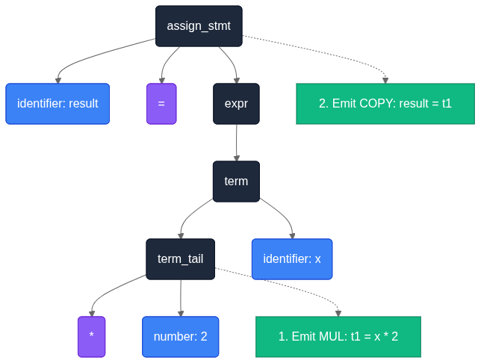
AST to Quadruple Transformation (result = x * 2)

4. Control Flow (Jumps and Labels)
Control structures (if/else and while) require translating nested, scoped blocks into a linear sequence of instructions using conditional branches (IFF - If False) and unconditional jumps (GOTO).

Translating if-else (genIfStmt):
  - The condition expression is evaluated into a temporary variable (e.g., t1).
  - The ICG emits (IFF, t1, _, L_Else). If the condition is false, execution jumps to the else block.
  - The then block's statements are traversed and quadruples emitted.
  - To bypass the else block after the then block finishes, (GOTO, _, _, L_End) is emitted.
  - The L_Else label is emitted via (LABEL, L_Else, _, _).
  - The else block's statements are traversed.
  - Finally, the L_End label is emitted.
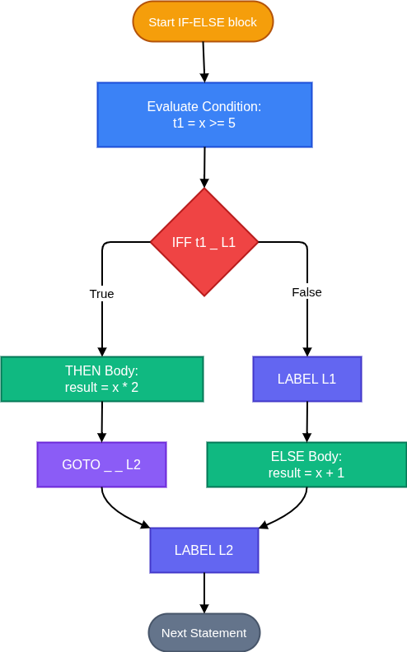
If/Else Statement ICG Translation

Translating while (genWhileStmt):
    - A start label (LABEL, L_Start, _, _) is emitted before evaluating the condition.
    - The condition is evaluated into a temporary variable (e.g, t2).
    - The loop escape branch is emitted: (IFF, t2, _, L_End).
    - The loop body is traversed and its quadruples are emitted.
    - At the end of the body, an unconditional jump forces re-evaluation: (GOTO, _, _, L_Start).
    - The exit label (LABEL, L_End, _, _) is emitted at the very end.
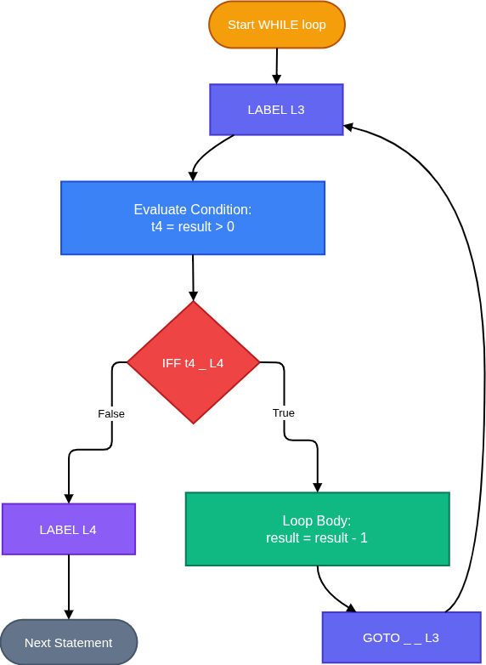
While Loop ICG Translation
This architecture cleanly transforms an arbitrarily complex hierarchical syntax tree into a flattened, assembly-like intermediate representation ready for target code generation or optimization.

1. CFG in BNF format
The Context-Free Grammar (CFG) used for our parser and subsequent ICG is LL(1)-compatible, derived by removing left-recursion and factoring.
<program> ::= <stmt_list>

<stmt_list> ::= <stmt> <stmt_list>
| ε

<stmt> ::= <decl_stmt>
| <assign_stmt>
| <if_stmt>
| <while_stmt>
| <return_stmt>

<decl_stmt> ::= int IDENTIFIER ;

<assign_stmt> ::= IDENTIFIER = <expr> ;

<if_stmt> ::= if ( <cond_expr> ) { <stmt_list> } <else_part>

<else_part> ::= else { <stmt_list> }
| ε

<while_stmt> ::= while ( <cond_expr> ) { <stmt_list> }

<return_stmt> ::= return <expr> ;

<expr> ::= <term> <expr_tail>

<expr_tail> ::= + <term> <expr_tail>
| - <term> <expr_tail>
| ε

<term> ::= <factor> <term_tail>

<term_tail> ::= * <factor> <term_tail>
| / <factor> <term_tail>
| ε

<factor> ::= NUMBER
| IDENTIFIER
| ( <expr> )

<cond_expr> ::= <expr> <rel_op> <expr>

<rel_op> ::= == | < | > | <= | >=

2. Source Code
This is the sample program (sample.elmo) written in our language, which will be compiled into Intermediate Code.
int x;
int result;
x = 10;
result = 0;

if (x >= 5) {
result = x * 2;
} else {
result = x + 1;
}

while (result > 0) {
result = result - 1;
}

return result;

3. Token List
This is the stream of tokens produced by our lexical analyzer (scanner) when processing sample.elmo. It serves as input to the parser.

Elmo — Phase 1: Scanning
══════════════════════════════════════════════════
file : sample.elmo
tokens : 55
══════════════════════════════════════════════════
TOKEN TYPE LEXEME LINE
----------------------------------------
KEYWORD int 1
IDENTIFIER x 1
PUNCTUATION ; 1
KEYWORD int 2
IDENTIFIER result 2
PUNCTUATION ; 2
IDENTIFIER x 3
OPERATOR = 3
NUMBER 10 3
PUNCTUATION ; 3
IDENTIFIER result 4
OPERATOR = 4
NUMBER 0 4
PUNCTUATION ; 4
KEYWORD if 6
PUNCTUATION ( 6
IDENTIFIER x 6
OPERATOR >= 6
NUMBER 5 6
PUNCTUATION ) 6
PUNCTUATION { 6
IDENTIFIER result 7
OPERATOR = 7
IDENTIFIER x 7
OPERATOR * 7
NUMBER 2 7
PUNCTUATION ; 7
PUNCTUATION } 8
KEYWORD else 8
PUNCTUATION { 8
IDENTIFIER result 9
OPERATOR = 9
IDENTIFIER x 9
OPERATOR + 9
NUMBER 1 9
PUNCTUATION ; 9
PUNCTUATION } 10
KEYWORD while 12
PUNCTUATION ( 12
IDENTIFIER result 12
OPERATOR > 12
NUMBER 0 12
PUNCTUATION ) 12
PUNCTUATION { 12
IDENTIFIER result 13
OPERATOR = 13
IDENTIFIER result 13
OPERATOR - 13
NUMBER 1 13
PUNCTUATION ; 13
PUNCTUATION } 14
KEYWORD return 16
IDENTIFIER result 16
PUNCTUATION ; 16
EOF 17
══════════════════════════════════════════════════

4. Parse Tree
This is the parse tree generated by our Recursive Descent parser. It acts as the input for our Intermediate Code Generator (ICG).
══════════════════════════════════════════════════
Elmo — Phase 2: Parse Tree
══════════════════════════════════════════════════
program
└── stmt_list
├── decl_stmt
│ ├── keyword 'int'
│ ├── identifier 'x'
│ └── punctuation ';'
└── stmt_list
├── decl_stmt
│ ├── keyword 'int'
│ ├── identifier 'result'
│ └── punctuation ';'
└── stmt_list
├── assign_stmt
│ ├── identifier 'x'
│ ├── operator '='
│ ├── expr
│ │ ├── term
│ │ │ ├── number '10'
│ │ │ └── term_tail
│ │ │ └── ε 'ε'
│ │ └── expr_tail
│ │ └── ε 'ε'
│ └── punctuation ';'
└── stmt_list
├── assign_stmt
│ ├── identifier 'result'
│ ├── operator '='
│ ├── expr
│ │ ├── term
│ │ │ ├── number '0'
│ │ │ └── term_tail
│ │ │ └── ε 'ε'
│ │ └── expr_tail
│ │ └── ε 'ε'
│ └── punctuation ';'
└── stmt_list
├── if_stmt
│ ├── keyword 'if'
│ ├── punctuation '('
│ ├── cond_expr
│ │ ├── expr
│ │ │ ├── term
│ │ │ │ ├── identifier 'x'
│ │ │ │ └── term_tail
│ │ │ │ └── ε 'ε'
│ │ │ └── expr_tail
│ │ │ └── ε 'ε'
│ │ ├── rel_op '>='
│ │ └── expr
│ │ ├── term
│ │ │ ├── number '5'
│ │ │ └── term_tail
│ │ │ └── ε 'ε'
│ │ └── expr_tail
│ │ └── ε 'ε'
│ ├── punctuation ')'
│ ├── punctuation '{'
│ ├── stmt_list
│ │ ├── assign_stmt
│ │ │ ├── identifier 'result'
│ │ │ ├── operator '='
│ │ │ ├── expr
│ │ │ │ ├── term
│ │ │ │ │ ├── identifier 'x'
│ │ │ │ │ └── term_tail
│ │ │ │ │ ├── operator '*'
│ │ │ │ │ ├── number '2'
│ │ │ │ │ └── term_tail
│ │ │ │ │ └── ε 'ε'
│ │ │ │ └── expr_tail
│ │ │ │ └── ε 'ε'
│ │ │ └── punctuation ';'
│ │ └── stmt_list
│ │ └── ε 'ε'
│ ├── punctuation '}'
│ └── else_part
│ ├── keyword 'else'
│ ├── punctuation '{'
│ ├── stmt_list
│ │ ├── assign_stmt
│ │ │ ├── identifier 'result'
│ │ │ ├── operator '='
│ │ │ ├── expr
│ │ │ │ ├── term
│ │ │ │ │ ├── identifier 'x'
│ │ │ │ │ └── term_tail
│ │ │ │ │ └── ε 'ε'
│ │ │ │ └── expr_tail
│ │ │ │ ├── operator '+'
│ │ │ │ ├── term
│ │ │ │ │ ├── number '1'
│ │ │ │ │ └── term_tail
│ │ │ │ │ └── ε 'ε'
│ │ │ │ └── expr_tail
│ │ │ │ └── ε 'ε'
│ │ │ └── punctuation ';'
│ │ └── stmt_list
│ │ └── ε 'ε'
│ └── punctuation '}'
└── stmt_list
├── while_stmt
│ ├── keyword 'while'
│ ├── punctuation '('
│ ├── cond_expr
│ │ ├── expr
│ │ │ ├── term
│ │ │ │ ├── identifier 'result'
│ │ │ │ └── term_tail
│ │ │ │ └── ε 'ε'
│ │ │ └── expr_tail
│ │ │ └── ε 'ε'
│ │ ├── rel_op '>'
│ │ └── expr
│ │ ├── term
│ │ │ ├── number '0'
│ │ │ └── term_tail
│ │ │ └── ε 'ε'
│ │ └── expr_tail
│ │ └── ε 'ε'
│ ├── punctuation ')'
│ ├── punctuation '{'
│ ├── stmt_list
│ │ ├── assign_stmt
│ │ │ ├── identifier 'result'
│ │ │ ├── operator '='
│ │ │ ├── expr
│ │ │ │ ├── term
│ │ │ │ │ ├── identifier 'result'
│ │ │ │ │ └── term_tail
│ │ │ │ │ └── ε 'ε'
│ │ │ │ └── expr_tail
│ │ │ │ ├── operator '-'
│ │ │ │ ├── term
│ │ │ │ │ ├── number '1'
│ │ │ │ │ └── term_tail
│ │ │ │ │ └── ε 'ε'
│ │ │ │ └── expr_tail
│ │ │ │ └── ε 'ε'
│ │ │ └── punctuation ';'
│ │ └── stmt_list
│ │ └── ε 'ε'
│ └── punctuation '}'
└── stmt_list
├── return_stmt
│ ├── keyword 'return'
│ ├── expr
│ │ ├── term
│ │ │ ├── identifier 'result'
│ │ │ └── term_tail
│ │ │ └── ε 'ε'
│ │ └── expr_tail
│ │ └── ε 'ε'
│ └── punctuation ';'
└── stmt_list
└── ε 'ε'
══════════════════════════════════════════════════

5. Intermediate Code Generator (Run-Time Output)
Below is the text representation of our compiler's runtime output for our ICG phase (showing the generated quadruples).
══════════════════════════════════════════════════
Elmo — Phase 3: Intermediate Code (Quadruples)
══════════════════════════════════════════════════

IDX OP ARG1 ARG2 RESULT
------------------------------------------------------------
0 DECL x _ _
1 DECL result _ _
2 COPY 10 _ x
3 COPY 0 _ result
4 GE x 5 t1
5 IFF t1 _ L1
6 MUL x 2 t2
7 COPY t2 _ result
8 GOTO _ _ L2
9 LABEL L1 _ _
10 ADD x 1 t3
11 COPY t3 _ result
12 LABEL L2 _ _
13 LABEL L3 _ _
14 GT result 0 t4
15 IFF t4 _ L4
16 SUB result 1 t5
17 COPY t5 _ result
18 GOTO _ _ L3
19 LABEL L4 _ _
20 RET result _ _
─────────────────────────────────────────────────────
Total Instructions: 21
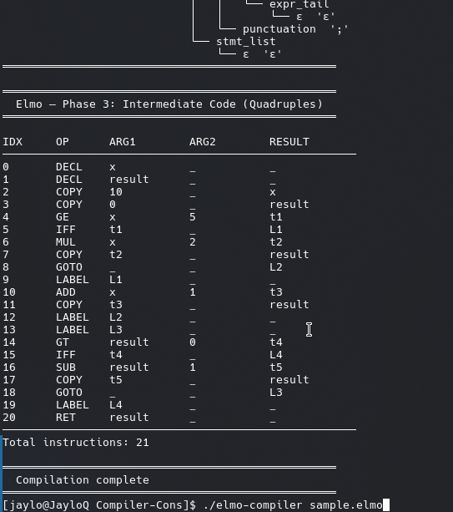
SCREENSHOT OF TERMINAL SHOWING THE QUADRUPLES TABLE
Elmo Code Repo

Member Roles
Task | Group Member
Task 1: ICG Architecture & Quadruples Design | Leo Munene
Task 2: Expressions & Temporary Variable Gen | Sandra Cherop
Task 3: Control Flow & Label Generation | Morris Ngumo
Task 4: Compilation Pipeline & Reporting | Eric Kumenda

